Chapter 19, Solution 63.

To get z₁₁ and z₂₁, consider the circuit below.

I₁ 1:3 I₂=0

+ +
+ +
V’₁ V’₂ 9 V₂
V₁ 4 - - - -

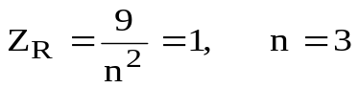
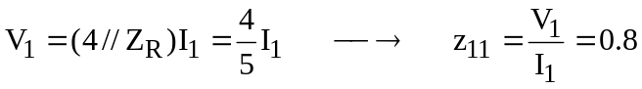

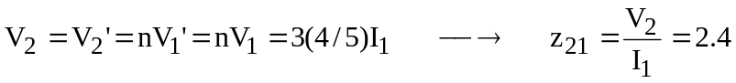

To get z₂₁ and z₂₂, consider the circuit below.

I₁=0 1:3 I₂

+ +
+ +
V’₁ V’₂ 9 V₂
V₁ 4 - - - -

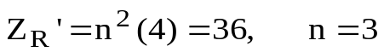
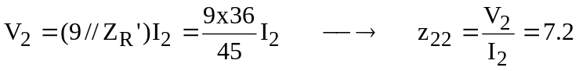

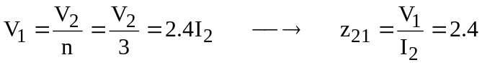

Thus,

